Association of Senates & Shoora and Equivalent Councils in Africa and the Arab World ( ASSECAA) Tenth Retreat
(Kingdom of Eswatini, 11 to 13 May 2023)

“The future of the Afro-Arab economies in light of the successive global economic crisis and ongoing global geopolitical tension and instability”.

Impacts of global economic crisis on emerging countries

I. Macroeconomic and social impacts

As governments around the world work to gradually recover from the effects of the covid-19 pandemic, the crisis in Ukraine that began on February 24, 2022, imposes additional challenges on developing economies and countries' efforts to recover from the health crisis and get back on track to meet the Sustainable Development Goals (SDGs) by 2030.

A report produced in April 2022 by the UN Department of Economic and Social Affairs (DESA) together with more than 60 international agencies, including within the UN system, and international financial institutions, set the alarm on the situation, especially for developing countries.

The report reveals that on average, the poorest developing countries pay around 14 per cent of revenue for interest on their debt, while the figure is 3.5 per cent for richer nations.

The pandemic forced governments to cut budgets for education, infrastructure and other capital spending. Fallouts from the war in Ukraine (such as higher energy and commodity prices, as well as renewed supply chain disruptions) will only exacerbate these challenges and spark new ones.

The war is also likely to result in further increases to debt distress and increased hunger, further widening “pandemic recovery gaps” that existed before the conflict.

Furthermore, it is estimated that one in five developing countries will not see their Gross Domestic Product (GDP) return to 2019 levels by the end of this year, even before absorbing the impacts of the Ukraine conflict, which is already affecting food, energy, and finance across the globe.

As said by Amina Mohamed, the Deputy UN Secretary General when launching the report, “There is no excuse for inaction at this defining moment of collective responsibility, to ensure hundreds of millions of people are lifted out of hunger and poverty. We must invest in access for decent and green jobs, social protection, healthcare and education leaving no one behind,”.

According to the World Economic Outlook (WEO, IMF, October 2022), “Russia’s invasion of Ukraine continues to powerfully destabilize the global economy. Beyond the escalating and senseless destruction of lives and livelihoods, it has led to a severe energy crisis in Europe that is sharply increasing costs of living and hampering economic activity”.

Gas prices in Europe have increased more than four-fold since 2021, with Russia cutting deliveries to less than 20 percent of their 2021 levels, raising the prospect of energy shortages over the next winter and beyond. More broadly, the conflict has also pushed up food prices on world markets, despite the recent easing after the Black Sea grain deal, causing serious hardship for low-income households worldwide, and especially so in low-income countries.

Global growth is forecast to slow from 3.4 percent in 2022 to 2.8 percent in 2023 and 3.0 percent in 2024 (WEO, IMF, April 2023). This is the weakest growth profile since 2001 except for the global financial crisis and the acute phase of the COVID-19 pandemic and reflects significant slowdowns for the largest economies. However, emerging market and developing economies are more resilient to this crisis than the advanced economies which are most impacted directly.

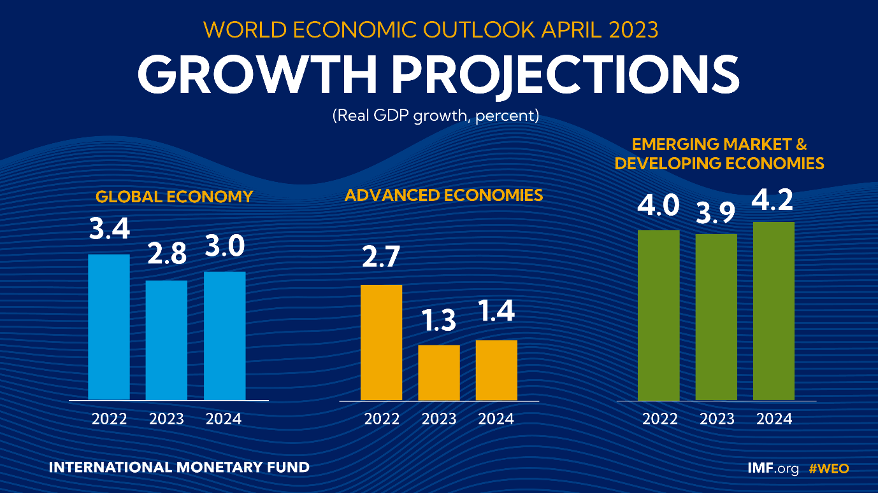

An analysis conducted by the UNDP in June 2022 assessed that “the crisis could reduce developing countrie’s productivity through a reduction in demand from Russia/Ukraine, higher import costs and a loss in competitiveness”. In particular, these countries are impacted through 5 mains interconnected channels:
- costs of imports have risen dramatically (+4%),
- tourism receipts are affected as Russia as accounted for an important share of developing countrie’s tourists like Seychelles,
- higher costs of refined crude/gas cancel out windfall gains: fuel prices rose by over 20% during the early weeks in some fuel importer countries,
- export markets could collapse, as some developing countries trading with Russia is affected by dampened demand and financial risks because of sanctions,
- jobs could be decimated, particularly in non-formal and among women.

II. Global Current crises risk assessment

With the global landscape dominated by manifesting risks, the World Economic Forum introduced this year three time frames for understanding global risks: 1) current crises (i.e. global risks which are already unfolding), 2) risks that are likely to be most severe in two years, and 3) risks that are likely to be most severe in 10 years.

According to the 2022-2023 Global Risks Perception Survey (GRPS), “Energy supply crisis”; “Cost-of-living crisis”; “Rising inflation”; “Food supply crisis” and “Cyberattacks on critical infrastructure” are among the top risks for 2023 with the greatest potential impact on a global scale (Figure 1.1).

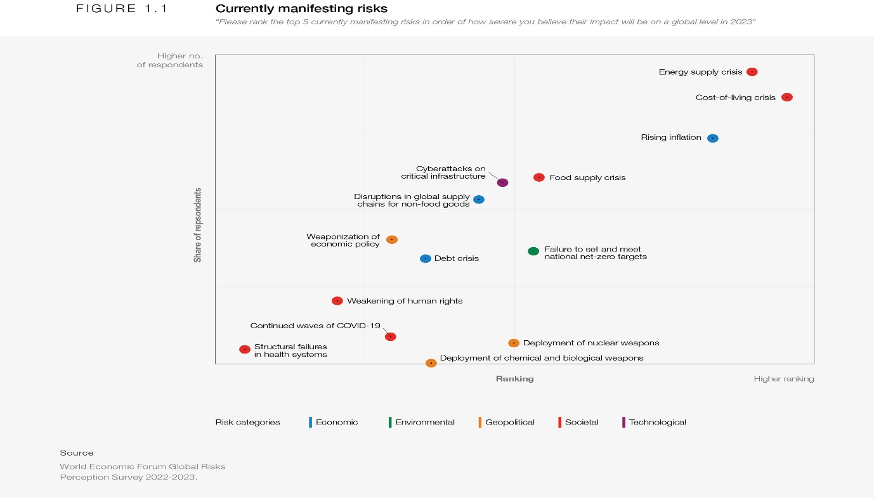

Our global “new normal” is a return to basics – food, energy, security – problems our globalized world was thought to be on a trajectory to solve. These risks are being amplified by the persistent health and economic overhang of a global pandemic; a war in Europe and sanctions that impact a globally integrated economy; and an escalating technological arms race underpinned by industrial competition and enhanced state intervention.

Longer-term structural changes to geopolitical dynamics – with the diffusion of power across countries of differing political and economic systems – are coinciding with a more rapidly changing economic landscape, ushering in a low-growth, low-investment and low-cooperation era and a potential decline in human development after decades of progress.

1.2 The path to 2025

The complex and rapid evolution of the global risks landscape is adding to a sense of unease.

Exploring the most severe global risks that many expect to play out over the next two years, within the context of the mounting impacts and constraints being imposed by the numerous crises felt today, the WEF assessed: cost-of-living crisis, economic downturn, geoeconomic warfare, climate action hiatus and societal polarization. We describe current trends associated with each risk, briefly cover the reasons behind them and then note their emerging implications and knock-on effects.

Cost-of-living crisis

Ranked as the most severe global risk over the next two years by GRPS respondents, a global Cost-of-living crisis is already here, with inflationary pressures disproportionately hitting those that can least afford it. Even before the COVID-19 pandemic, the price of basic necessities (non-expendable items such as food and housing) were on the rise.¹Costs further increased in 2022, primarily due to continued disruptions in the flows of energy and food from Russia and Ukraine. To curb domestic prices, around 30 countries introduced restrictions, including export bans, in food and energy last year, further driving up global inflation.

Despite the latest extension, the looming threat of Russia pulling out of the Black Sea Grain Export Deal has also led to significant volatility in the price of essential commodities.
Although global supply chains have partly adapted, with pressures significantly lower than the peak experienced in April last year,³price shocks to core necessities have significantly outpaced general inflation over this time (Figure 1.4).

The FAO Price Index hit the highest level since its inception in 1990 in March last year. Energy prices are estimated to remain 46% higher than average in 2023 relative to January 2022 projections.

Economic impacts are often cushioned by expansive fiscal policy and government programmes in countries that can afford them.

The resulting pressure on fiscal balances may exacerbate debt sustainability concerns, leaving emerging and developing countries with far less fiscal room to protect their populations in the future.

Both affordability and availability of basic necessities can stoke social and political instability. Last year, the increase in fuel prices alone led to protests in an estimated 92 countries, some of which resulted in political upheaval and fatalities, alongside strikes and industrial action.

Economic downturn

The IMF’s most recent projections anticipate a decline in global inflation from almost 9% in 2022 to 6.5% this year and 4.1% in 2024, with a sharper disinflation in advanced economies.

However, downside risks to the outlook loom large. The complexity of inflationary dynamics is creating a challenging policy environment for both the public sector and central banks, given the mix of demand and supply-side drivers, including a prolonged war in Ukraine and associated energy-supply crunch, potential for escalating sanctions, and continued bottlenecks from a lingering pandemic or new sources of supply-side controls.

With a rapid rise in rates, the risk of unintended consequences and policy error is high, with possible overshoot leading to a deeper and more prolonged economic downturn and potential global recession.

Climate action hiatus

According to the Intergovernmental Panel on Climate Change (IPCC), the chance of breaching the 1.5°C target by as early as 2030 stands at 50%. Current commitments made by the G7 private sector suggest an increase of 2.7°C by mid-century, way above the goals outlined in the Paris Agreement.

Recent events have exposed a divergence between what is scientifically necessary and what is politically expedient. Current pressures should result in a turning point, encouraging energy-importing countries to invest in “secure”, cleaner and cheaper renewable energy sources.

Indeed, with 1.2°C of warming already in the system, the compounding effect of a changing climate is already being felt, magnifying humanitarian challenges such as food insecurity, and adding another hefty bill to already stretched fiscal balances.

Despite plans for a global goal on adaptation to be agreed at COP28, there has been insufficient progress towards the support required for infrastructure and populations already affected by the fallout from climate change. Adaptation has not been adequately funded, with 34% of climate finance currently allocated to adaptation worldwide.

Societal polarization

“Erosion of social cohesion and societal polarisation” has been climbing in the ranks of perceived severity in recent years. Defined as the loss of social capital and fracturing of communities leading to declining social stability, individual and collective wellbeing and economic productivity.

Consequences of societal polarization are vast, ranging from a drag on growth to civil unrest and deepening political fissures.

1.3 Looking ahead

Shocks of recent years (most notably, the war in Ukraine and COVID-19 pandemic) have reflected and accelerated an epochal change to the global order. Risks that are more severe in the short term are embedding structural changes to the economic and geopolitical landscape that will accelerate other global threats faced over the next 10 years.

And as the confluence of current crises distracts focus and resources from risks arising over the medium to longer-term horizon, we may face increasing burdens on natural and human ecosystems. Some of these risks are close to a tipping point, but there is a window to shaping a more secure future.

An UNDP analysis concluded that to kick-start a historic “big push”, countries and their development partners must focus on 3 collectively-reinforcing priorities:
- Reframe development finance, by enhancing domestic resource mobilization, re-channeling additional Special drawing rights (SDRs) issued by the International Monetary Fund (IMF), and innovative market-based and blended options,
- Consistent investment in resilience, by promoting initiatives that enable developing countries to fully utilize its natural resources wealth to direct and finance economic development, taking advantage of planet-friendly financing mechanisms like blue-carbon markets and green financing, focusing on climate risk-sensitive investment, de-risking and impact investment,
- Prioritize structural economic transformation
« The set of fundamental changes in economic and social structures that promote equitable and sustainable development » and regional integration, by harnessing digital technologies and promote free and fair competition, intensifying support to regional integration and economic diversification (unlock untapped potential growth in some sectors: manufacturing, ICT, agriculture, financial services. Mining, etc), mobilizing the resources to fill persistent critical gaps (technology, skill and infrastructure) that constraint countries’ development.
- Invest in Human Capital and Physical capital (infrastructures) so as to preserve the global mass of Capital: the notion of capital accumulation (physical capital, human capital and natural capital): the rent from the exploitation of natural resources will have to be invested in physical capital and human capital, so as to preserve the global mass of K.

Source: Global risks report 2023. World Economic Forum

